Curriculum Vitae for John A. Lynn II
6 March 2019

Contents of this CV
2017 Awards Received
Contact Information
Education
Academic Positions Held
Teaching Awards Received
Orders Received
Offices Held
Work with US and Other Militaries
Books Published
Published Articles, Chapters, and Papers
Teaching the History of Terrorism

2017 Awards Received
Samuel Eliot Morison Prize
The Society for Military History awarded John Lynn its Samuel Eliot Morison Prize for 2017. The Morison is given to one individual each year in recognition of his or her career accomplishments and contributions. It is their most honored prize.
http://www.smh-hq.org/awards/morison.html

NEH Public Scholar Grant
The National Endowment for the Humanities awarded John Lynn a Public Scholar Grant in August 2017 for his project “The Other Side of Victory: A History of Surrender from Medieval Combat to Modern Terrorism.”
https://www.washingtonpost.com/entertainment/books/2017-neh-grants-encourage-great-scholarship-for-nonscholars-to-enjoy/2017/08/01/6e0e74f2-76e9-11e7-8f39-eeb7d3a2d304_story.html

Contact Information
Cell Phone  217-778-7333  Email  johnlynn@illinois.edu | Home  910 West Hill Street  Champaign, IL 61821  Phone: 217-356-6336
University of Illinois at Urbana-Champaign  Department of History  309 Gregory Hall  810 S. Wright St.  Urbana, IL 61801  Phone: 217-333-1155  Fax: 217-333-2297 | Program in Arms Control, Domestic, and International Security  350 Armory Building  505 E. Armory Avenue  Champaign, IL 61820  Phone: 217-333-7086  Fax: 217-244-5157

Education
University of California at Los Angeles Ph.D. 3/73
University of California at Davis M.A. 3/67
University of Illinois at Urbana-Champaign B.A. 8/64

Academic Positions Held
Professor Emeritus of History–University of Illinois at U-C 6/09-
Teaching part-time at the University of Illinois 8/12-
(Professor Emeritus of Political Science–University of Illinois at U-C 8/17-12/17)
Distinguished Professor of Military History–Northwestern University 9/09-8/12
Faculty, Program in Arms Control, Domestic and
International Security, University of Illinois at U-C 8/80-
Oppenheimer Professor of Warfighting Strategy–US Marine
Corps University, Quantico, VA 8/94-7/95
Professor of History–University of Illinois at U-C 8/91-6/09
Associate Professor of History–University of Illinois at U-C 8/83-8/91
Assistant Professor of History–University of Illinois at U-C 8/78-8/83
Assistant Professor of History–University of Maine, Orono 9/73-5/77
Visiting Asst. Prof. of History–Indiana University, Bloomington 8/72-6/73

Teaching Awards Received
Campus Award for Excellence in Undergraduate Teaching, 2001.
Conferred by the Provost of the University of Illinois at Urbana-Champaign.
Dean’s Award for Excellence in Undergraduate Teaching, 2000-2001.
Conferred by the College of Liberal Arts and Sciences at the University of Illinois.
Humanities Award for Excellence in Teaching, 2001.
Conferred by the Humanities Council, University of Illinois.
Queen Prize for Excellence in Graduate Teaching from the Department of
History, 2005
Delta Sigma Omicron Distinguished Teaching Award, 2008
For teaching students with disabilities.
University of Illinois List of Teachers Ranked as Excellent by their Students:
fall semester 1995, spring semester 1997, fall semester 1997, (on sabbatical leave fall 1998), spring semester 1999, fall semester 1999, spring semester 2000, spring semester 2001, fall semester 2001, spring semester 2003, fall semester 2003, spring semester 2004, spring semester 2005, (on sabbatical leave fall 2005 and spring 2006), spring semester 2007, fall semester 2007, spring semester 2008, fall semester 2008 (teaching only at Northwestern University from fall 2009 through spring 2012), fall semester 2013, fall semester 2014 (rated as “outstanding”), fall semester 2015, spring 2017.
(John Lynn has been on the List of Teachers Rated as Excellent every academic year he has been in the classroom at the University of Illinois, save two, since 1995.)

Orders Received
Palmes Académiques at the rank of chevalier
Awarded by the French government in 2004.
(The order of the Palmes Académiques was established by Napoleon in 1808. It is one of the five ministerial orders maintained by the French government.)
Ouissam Alaouite at the rank of commandeur
Awarded by His Majesty Mohammed VI, King of Morocco, in 2006.
(The civil and military order of Ouissam Alaouite, founded in 1913, is the oldest awarded by the Moroccan monarchy.)

Offices Held
United States Commission on Military History —
President, 2003-2007.
Vice-President, 2002-2003.
Trustee, 1999-2002.
Chair, Bibliographical Committee and U.S. Representative,
Bibliographical Committee, International Committee on Military History, 2000-2003.
Society for Military History
Vice-President, Society for Military History, 2005-2007.
Trustee, Society for Military History, 2001-2005.
Midwest Regional Coordinator, Society for Military History, 1989-1996.
History Subcommittee, Defense Coordination Committee for Morocco
Member, 2005-2008.
(This committee coordinates activities and relations between the Pentagon and the Kingdom of Morocco.)
Editorial Boards
British Journal for Military History
Journal of Military History
International History Review
MHQ: The Quarterly Journal of Military History
Minerva: Journal of Women and War

Work with US and Foreign Militaries
In addition to his academic work, John Lynn has lectured at the following advanced military schools in the United States:
USMC Command and Staff College
USMC School of Advanced Warfighting
USMC War College
US Naval Postgraduate School
US Army Command and General Staff College
US Army School for Advanced Military Studies
US Army Combat Studies Institute.
US Army Strategic Studies Institute, Army War College
US Joint Forces Command
During the academic year 1994-95, he held the Oppenheimer Chair of Warfighting Strategy at the Marine Corps University, Quantico, VA. Parameters, published by the US Army War College, Military Review, published by the US Army Combined Arms Center, and the Marine Corps Gazette have published articles by Lynn on terrorism, insurgency, and counterinsurgency.

John Lynn has also lectured at or worked with military institutions in France, England, the Netherlands, Canada, Japan, Australia, and Morocco.

Current Book Projects
Surender: A Military History with Cambridge University Press. Projected completion 2021.

Books Published
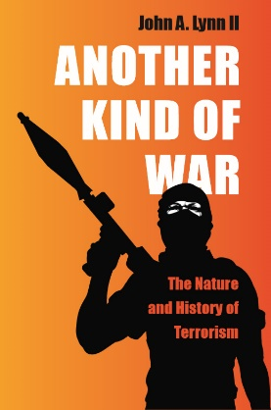 | Another Kind of War: The Nature and History of Terrorism (New Haven, CT: Yale University Press, 2019)
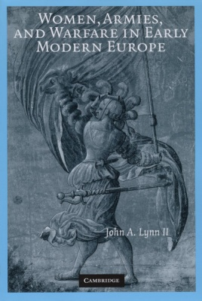 | Women, Armies, and Warfare in Early Modern Europe (Cambridge: Cambridge University Press, 2008).  Winner of 2009 Phi Alpha Theta Book Prize.

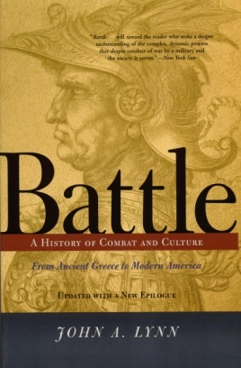 | Battle: A History of Combat and Culture (Boulder, CO: Westview Press, 2003), Pp. xxv, 399. Revised and expanded paperback edition, 2004.  Winner of 2004 Phi Alpha Theta Book Prize;  Awarded prize as 2003 Finalist in Adult Non-Fiction by Society of Midland Authors;  The September 2005 issue of The International History Review was devoted to a discussion of Battle.  A further revised edition is available in French as De la guerre : Une histoire du combat des origines à nos jours (Paris: Tallandier, 2006); a Korean edition, published by Chungaram Media also appeared in 2006.

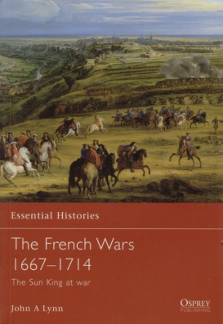 | The French Wars 1667-1714: The Sun King at War (Oxford: Osprey Publishing, 2002). Pp. 95.

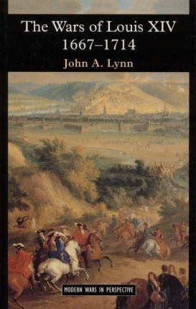 | The Wars of Louis XIV, 1667-1714 (London: Longman, Ltd., 1999), Pp. xiii, 421.  A French edition is available as Les guerres de Louis XIV (Paris: Perrin, 2010). A Polish edition is available as Wojny Ludwika XIV, 167-1714 (NapoleonV, 2015).

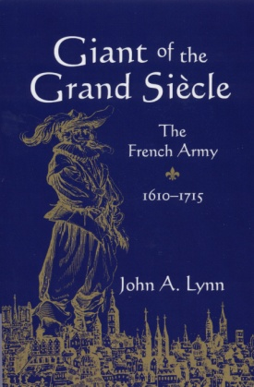 | Giant of the Grand Siècle: The French Army, 1610-1715 (Cambridge: Cambridge University Press, 1997; second printing, with corrections, 1998, paperback edition published 2006), Pp. xvii, 651.  Winner of 1998 Phi Alpha Theta Book Prize.

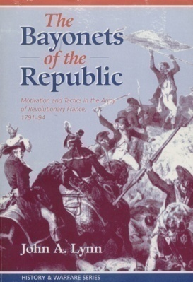 | The Bayonets of the Republic: Motivation and Tactics in the Army of Revolutionary France, 1791-94, revised edition (Boulder, CO: Westview Press, 1996; first edition published by the University of Illinois Press in 1984), Pp. xii, 356.  Winner of 1985 Phi Alpha Theta Book Prize.  A Polish edition is available as Bagnety Republiki: Motywacja i taktyka w armii rewolucyjnej Francji (1791-1794) (NapoleonV, 2016).

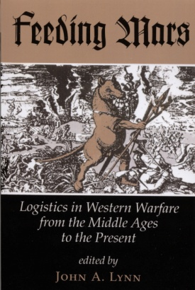 | (editor) Feeding Mars: Logistics in Western Warfare from the Middle Ages to the Present (Boulder, Colorado: Westview Press, 1993). Pp. xii, 326.

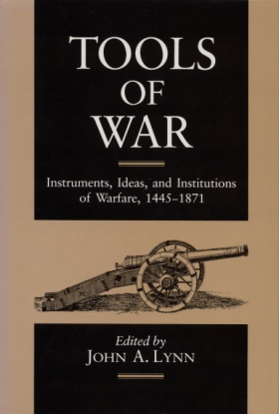 | (editor) The Tools of War: Ideas, Instruments, and Institutions of Warfare, 1445-1871 (Urbana, Illinois: University of Illinois Press, 1990). Pp. xii, 262.

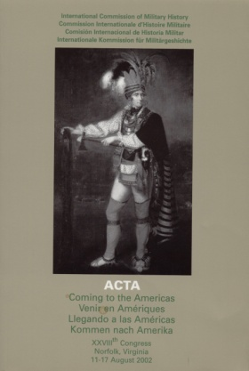 | (editor) ACTA of the XXVIIIth Congress of the International Commission of Military History (Chicago: McCormack Foundation, August 2003).

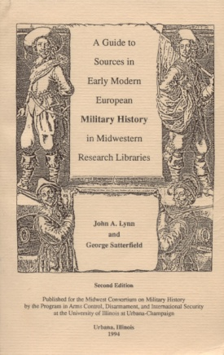 | (with George Satterfield) A Guide to Sources in Early Modern European Military History in Midwestern Research Libraries, 2nd ed.(Urbana, Illinois: Program in Arms Control, Disarmament, and International Security, 1994) [First edition, 1991]. Pp. ix, 337.

Published Articles, Chapters, and Papers
84) “What does Surrender Mean?” keynote address delivered at the conference “Cesser-le-Feu, Cesser les Combats?,” Paris, 27 November 2018. Conference supported by the Institut Guerre et Paix en Sorbonne and the Section Historique de la Défense. To be published in the acta of that conference.

83) “The Intersection of Military History and the History of Emotions: Reconsidering Fear and Honor,” keynote address delivered at the conference, “Émotions en Bataille. XVIe-XVIIIe Siècles,” Montréal, 23 October 2018, to be published in the acta of that conference.

82) “Les âges du terrorisme,” in Bruno Cabanes, Thomas Dodman, Hervé Mazurel, and Gene Tempest, Une histoire de la guerre XIXe-XXIe siècles (Paris: Seuil, 2018), pp. 227-241.

81) “Réflexions sur Giant of the Grand Siècle: Un ouvrage d’histoire militaire,” in Hervé Drévillon, Bertrand Fonck, and Jean-Philippe Cénat, eds., Les dernières guerres de Louis XIV (Presses universitaires de Rennes, 2017), pp. 29-44.

80) “The French Army of Louis XIV to 1688,” chapter 5 of the West Point History of Warfare, digital textbook on military history (New York: Rowan Technology, 2014).
é
79) “League of Gentlemen,” Military History (November 2012), pp. 36-43.

78) “Fear and Outrage as Terrorists’ Goals,” Parameters 42, No. 1 (Spring 2012), pp. 51-62.

77) “The Battle Culture of Forbearance, 1660-1789,” in Warfare and Culture in World History, Wayne E. Lee, ed. (New York: New York University Press, 2011), pp. 89-114.

76) “The Other Side of Victory: Surrender during the Wars of Louis XIV,” in The Projection and Limitations of Imperial Powers, Frederick C. Schneid, ed., (Leiden: Brill, 2012), pp. 51-67.

75) “Honorable Surrender in Early Modern European History, 1500-1789,” in How Fighting Ends: A History of Surrender, Hew Strachan and Holger Afflerbach, eds., (Oxford: Oxford University Press, 2012), pp. 99-112.

74) “Essential Women, Necessary Wives, and Exemplary Soldiers: The Military Reality and Cultural Representation of Women’s Military Participation 1600-1815,” Chapter 4 of Barton Hacker and Margaret Vining, eds., Companion to Women’s Military History (Leiden: Brill, 2012), pp. 93-136.

73) “The Grand Strategy of the Grand Siècle: Learning from the Wars of Louis XIV,” The Shaping of Grand Strategy: Policy, Diplomacy, and War, Williamson Murray, Richard Hart Sinnreich, James Lacey, eds., (Cambridge: Cambridge University Press, 2011), pp. 34-62.

72) AHR featured review of Yuval Noah Harari, The Ultimate Experience: Battlefield Revelations and the Making of Modern War Culture, 1450–2000 (2008), American Historical Review 114, no. 3 (June 2009), pp. 708-10.

71) “Defense Policy: Regenerating the American Military,” ACDIS International Security Policy Brief series, No. 2 (May 2008). http://www.acdis.uiuc.edu/Research/PBs/Military.shtml

70) “Breaching the Walls of Academe: The Purposes, Problems, and Prospects of Military History,” Academic Questions (Winter 2007-8).

69) “Women in War,” in Military History, (October 2007), pp. 60-66.

68) “Revisiting the Great Fact of War and Bourbon Absolutism: The Growth of the French Army during the Grand siècle” in Guerra y sociedad en la monarchia hispanica: Política, estrategia y cultura en la Europa moderna (1500-1700), Enrique Garcia Hernán and Davide Maffi, eds. (Madrid: 2006), vol. 1, pp. 49-74.

67) “Does Napoleon Really Have Much to Teach Us?” Land and Sea Power in the Age of the Battle of Trafalgar, ACTA of the XXXIst Congress of the International Commission of Military History (Madrid: 2006), pp. 599-608.

66) “Discourse, Reality, and the Culture of Combat,” The International History Review 27, no. 3 (September 2005), pp. 475-80. [This issue was devoted to a number of commentaries on John A. Lynn, Battle: A History of Combat and Culture.]

65) “Patterns of Insurgency and Counter-Insurgency,” in Military Review (July/August 2005), pp. 22-27.
This piece also appeared in translation as:
“Las Tendencias de la Insurgencia y Contrainsurgencia,” in Military Review, Hispano-americana, Revista profesional del ejército de EE. UU. (November/December 2005), pp. 34-40. (Spanish edition of #50.);
“Os Modelos de Insurreição e de Contra-Insurreição,” Military Review, Brazilian Edition (November/December 2005), pp. 36-42. (Portuguese edition of #50.); and
“داضلما ليدبلاو نايصعلاةيكولسو طانمأ,” in Military Review, Arabic, 2nd Edition (2006), pp. 31-43. (Arabic edition of #50.)

This article is currently being used by the military, including the Air University’s Air Command and Staff College's Distant Learning Program.

64) “L’armée et l’évolution économique,” Actes, XXXe Congrès International d’Histoire Militaire: Aspects économiques de la défense à travers les grands conflits mondiaux (Rabat, Morocco: 2005), pp. 592-594.

63) “What War Should Be, What War Really Is,” in Turning Victory Into Success: Military Operations After the Campaign, ed. Brian M. De Toy (Fort Leavenworth, KS: Combat Studies Institute Press, 2005), pp. 43-57.

62) “Seeing War as We Want It to Be: An Obstacle to Learning the Right Lessons?,” in NIDS Military History Studies Annual, no. 8 (March 2005), pp. 71-91. [NIDS is the National Institute for Defense Studies, Tokyo, Japan].

61) “Soul of the Sepoy,” MHQ, The Quarterly Journal of Military History, 15, no. 3 (Winter 2005), pp. 46-55.

60) “Les enjeux d’une approche culturelle de l’histoire militaire,” in Séminaires de D.E.A. “Evolution des mondes modernes,” Année 2003-2004, Université Paris-Sorbonne, pp. 1-12.

59) “La guerre entre réalité et illusion: comment voir la défaite en face?,” in Séminaires de D.E.A. “Evolution des mondes modernes,” Année 2003-2004, Université Paris-Sorbonne, pp. 13-26.

58) “A View from Above: Watersheds in the Evolution of War and Military Institutions during the Twentieth Century,” in War in the Twentieth Century: Reflections at Century’s End, Michael Hennessy and B.J.C. McKercher, eds. (Praeger: Westport, CT, 2003).

57) “Le discours et la realité de la guerre: un modèle culturel,” in Combattre, Gouverner, Ecrire: Etudes réunies en l’honneur de Jean Chagniot, Commission française d’histoire militaire, ed. (Paris: Economica, 2003), pp. 487-502.

56) “The Heart of the Sepoy: The Adoption and Adaptation of European Military Practice in South Asia, 1740-1805,” in The Diffusion of Military Technology and Ideas, Emily O. Goldman and Leslie C. Eliason, eds. (Stanford: Stanford University Press, 2003), pp. 33-62.

55) “Ideals of Battle in an Age of Elegance,” MHQ, The Quarterly Journal of Military History, 15, no. 3 (Winter 2003), pp. 34-45.

54) Two entries in Amazons to Fighter Pilots A Biographical Dictionary of Military Women, ed. Reina Pennington (Westport, CT: Greenwood, 2003).

53) “A Brutal Necessity?: The Devastation of the Palatinate, 1688-1689,” in Civilians in the Path of War, Mark Grimsley and Clifford Rogers, ed. (Lincoln, NE: University of Nebraska Press, 2002), pp. 79-110.

52) “Guerre et culture, ‘Lumières’ et Romanticisme dans la pensée militaire,” in La plume et le sabre, eds. Michel Biard, Annie Crépin, and Bernard Gainot (Paris: Sorbonne, 2002), pp. 327-344.

51) “The Treatment of Military Subjects in Diderot’s Encyclopédie,” Journal of Military History 65, no. 1 (January 2001), pp. 131-65.

50) “Forging the Western Army in Seventeenth-Century France,” in The Dynamics of Military Revolution, 1300-2050, Williamson Murray and McGregor Knox, eds. (Cambridge University Press: 2001), pp. 35-56.
This book was later translated and published in Japanese in 2004.

49) “The Tapissier de Notre Dame,” MHQ, The Quarterly Journal of Military History, 13, no. 3 (spring 2001), pp. 76-85.

48) Eight entries for the Oxford Companion to Military History, ed. Richard Holmes (Oxford: Oxford University Press, 2001).

47) “Reflections on the History and Theory of Military Innovation and Diffusion,” in Bridges and Boundaries: Historians, Political Scientists, and the Study of Interantional Relations, Colin Elman and Miriam Fendius Elman, eds. (Cambridge, MA: MIT Press, 2001), pp.359-382.

46) “International Rivalry and Warfare, 1700-1815,” in The Short Oxford History of Europe: Eighteenth-Century Europe, T.C.W. Blanning, ed. (Oxford: Oxford University Press, 2000), pp. 178-217.

45) “Evolution de l’armée du roi,1659-1672” Histoire, Economie et Société 19, no. 4 (4e trimestre 2000), pp. 481-95.

44) “Napoleonic Warfare, 1805-1807: Model or Special Case?,” in Consortium on Revolutionary Europe, 1750-1850: Selected Papers 1998, eds. Kyle Eidahl and Donald Horward (Tallahassee, Florida: 1998), pp. 97-105.

43) Three entries in Imagining the Twentieth Century, eds. Charles C. Steward and Peter Fritzsche (Urbana: University of Illinois Press, 1997).
Reprint of “Disillusion” from Imagining the Twentieth Century, eds. Charles C. Steward and Peter Fritzsche, in America West Airlines Magazine, November 1998, pp. 46 & 48.

42) “The Embattled Future of Academic Military History,” Journal of Military History 61, no. 4 (October 1997), pp. 777-89.

41) “War, Military, Forces, and the Formation of French Absolutism, 1635-1659,” in Bellum Tricennale: The Thirty Years’ War (Prague: 1997), pp. 65-76.

40) “War of Annihilation, War of Attrition, and War of Legitimacy: A Neo-Clausewitzian Approach to Twentieth-Century Conflicts,” Marine Corps Gazette 80, no. 10 (October 1996), pp. 64-71.

39) “The Evolution of Army Style in the Modern West, 800-2000,” International History Review 18, no. 3 (August 1996), pp. 505-45.
Translated into French as “L’évolution du style des armées dans l’Occident moderne, 800-2000,” in La science et la guerre: l’impact de la technologie militaire. (Canadian Armed Forces: 2004).

38) “The Sun King’s Star Wars,” MHQ, The Quarterly Journal of Military History 7, no. 4 (summer 1995), pp. 88-97.

37) Three entries in The Historical Dictionary of the War of the Spanish Succession, eds. Linda Frey and Marcia Frey (Westport, Conn.: Greenwood Press, 1995), pp. 125-26, 237-38, 458-60..

35 & 36) Chapters 10 and 11, Cambridge Illustrated History of Western Warfare, Geoffrey Parker, ed. (Cambridge: Cambridge University Press, 1995), pp. 164-213.

34) Chapter 6, “Revolution in Warfare During the Age of the French Revolution,” in Warfare in the Western World: Military Operations from 1600 to 1871, by Robert Doughty, Ira Gruber, Flint, Grimsley, Herring, Horward, Lynn, and Murray (New York: D.C. Heath, 1995), pp. 173-194.

33) “Recalculating French Army Growth During the Grand siècle, 1610-1715,” French Historical Studies 18, no. 4 (Fall 1994), pp. 881-906.
Reprinted in The Military Revolution Debate, Clifford Rogers, ed. (Boulder, Colorado: Westview Press, 1995), pp. 117-49.

32) “A Quest for Glory: The Formation of Strategy under Louis XIV, 1661-1715,” in The Making of Strategy: Rulers, States, and War, Williamson Murray, MacGregor Knox, and Alvin Bernstein, eds. (Cambridge: Cambridge University Press, 1994), pp. 178-204.

31) “How War Fed War: The Tax of Violence and Contributions during the Grand Siècle,” Journal of Modern History 65, no. 2 (June 1993), pp. 286-310.

30) “The History of Logistics and Supplying War,” in Feeding Mars (1993), John A. Lynn, ed., pp. 9-27.

29) “Food, Funds, and Fortresses: Resource Mobilization and Positional Warfare in the Campaigns of Louis XIV,” in Feeding Mars (1993), John A. Lynn, ed., pp. 137-159.

28) “Valmy,” MHQ, The Quarterly Journal of Military History 5, no. 1 (autumn 1992), pp. 88-97.

27) “Soldiers on the Rampage,” MHQ, The Quarterly Journal of Military History 3, no. 2 (winter 1991), pp. 92-101.

26) “The trace italienne and the Growth of Armies: the French Case,” Journal of Military History, July 1991, pp. 297-330.
Reprinted in The Military Revolution Debate, Clifford Rogers, ed. (Boulder, Colorado: Westview Press, 1995), pp. 169-99.

25) “Clio in Arms: The Role of the Military Variable in Shaping History,” Journal of Military History, January 1991, pp. 83-95.

24) “Contributions: A Missing Link in the Evolution of War Finance under Louis XIV,” in Proceedings of the Annual Meeting of the Western Society for French History, vol. 18, ed. Gordon Bond (Auburn, Alabama: 1991), pp. 130-35.

23) “The Pattern of Army Growth, 1445-1945,” in Tools of War (1990), John A. Lynn, ed., pp. 1-27.

22) “En avant! The Origins of the Revolutionary Attack,” in Tools of War (1990), John A. Lynn, ed., pp. 154-176.

21) “The Strange Case of the Maiden Soldier of Picardy,” MHQ, The Quarterly Journal of Military History 2, no. 3 (spring 1990), pp. 54-56.
Reprinted in The Experience of War, ed. Robert Cowley (New York: 1992).

20) “Towards an Army of Honor: The Moral Evolution of the French Army 1789-1815,” French Historical Studies 16, no. 1 (Spring 1989), pp. 152-73, 179-82.
(This was the “Forum” for the spring issue, meaning that the article was followed by a critique by Owen Connelly, to which I then responded.)

Republished as Chapter 8, in Frederick C. Schneid, ed., Warfare in Europe 1792–1815 (Aldershot, England: Ashgate, 2007).

19) “Louis XIV and the Fallacies of Absolute Security,” Swords and Ploughshares, October, 1989, pp. 5-7.

18) “The Sans-Culotte Solution,” MHQ, The Quarterly Journal of Military History, 1, no. 4 (summer 1989), pp. 76-87.

17) “A Conflict of Principles: The Army of the Revolution and the Army of the Empire,” in Proceedings of the Consortium on Revolutionary Europe (Gainesville, Florida: 1989), pp. 507-19.

16) “Vauban,” MHQ, The Quarterly Journal of Military History 1, no. 2 (winter 1989), pp. 50-61.

15) “Learning from the Last War: The New Military Critique of the Vietnam Conflict,” Swords and Ploughshares, October 1988, pp. 11-13.

14) “World War I and World War II as Historical Metaphor,” Swords and Ploughshares, March 1987, pp. 4-6.

13) “On Military History,” Swords and Ploughshares, March 1987, pp. 10-13.

12) “Tactical Evolution in the French Army, 1560-1660,” French Historical Studies, fall 1985, pp. 176-191.

11) Ten entries in A Historical Dictionary of the French Revolution, 1789-
1799, 2 vols., Samuel F. Scott and Barry Rothaus, eds. (Westport, Conn.: Greenwood Press, 1985).

10) “An Aspect of the Political Education of the French Army: The Distribution of Political Journals 1793-1794,” in Proceedings of the Consortium on Revolutionary Europe (Gainesville, Florida: 1984), pp. 75-90.

9) “The Growth of the French Army during the Seventeenth Century,” Armed Forces and Society, summer 1980, pp. 568-85.

8) “Military History in the Classroom: A Strategy for Enrollments,” Military Affairs, December 1979, pp. 202-3.

7) “Self-Image and Weaponry: The French Fascination with the Pike, 1724-1794,” in Colloquium on Military History: Proceedings, ed., Charles Balesi (Chicago: 1979), pp. 21-36.

6) “The Pattern of French Military Reform, 1750-1790,” at the at the February 1974 Consortium on Revolutionary Europe, 1750-1850 and published in the Proceedings of the Consortium on Revolutionary Europe (Gainesville, Florida: 1978), pp. 113-128.

5) “French Opinion and the Military Resurrection of the Pike,” Military Affairs, February 1977, pp. 1-7.

4) “Reconstructing a Maine Lumber Camp of 1900: The Diorama as a Historical Medium,” Journal of Forest History, October 1976, pp. 191-202.

3) “The Publications of the Section Historique, 1899-1915,” Military Affairs, April 1973, pp. 56-59.

2) “Esquisse sur la tactique de l’infanterie,” Annales historiques de la Révolution française, November-December, 1972, pp. 537-66.

1) “French Armor, 1940,” Military Review, December, 1967, pp. 78-84.

Teaching the History of Terrorism
Publications and projected publications on insurgency and terrorism
Another Kind of War: An Introduction to the History of Terrorism, (New Haven: Yale University Press, forthcoming July 2019).

“Les âges du terrorisme,” in Bruno Cabanes, Thomas Dodman, Hervé Mazurel, and Gene Tempest, Une histoire de la guerre XIXe-XXIe siècles (Paris: Seuil, 2018), pp. 227-241.

“Fear and Outrage as Terrorists’ Goals,” Parameters 42, No. 1 (Spring 2012), pp. 51-62.

“Patterns of Insurgency and Counter-Insurgency,” in Military Review (July/August 2005), pp. 22-27.

Papers and presentations given on the history of terrorism
“Is Terrorism War: Is a ‘War on Terrorism” a War?,” Sorbonne, Université Paris I, 29 November 2018.

“On Terrorism,” Sorbonne, Université Paris I, 23 November 2015.

“Terrorism as World Military History, 1848-1914 and Beyond,” at the conference “Straddling the East and West: Building a World Military History in the 100th Anniversary of the Great War,” held at Istanbul Sehir Universitesi, 10-12 June 1015.

Teaching the history of terrorism
Advanced course in the history of terrorism taught at the University of Illinois, 2003-2008, Northwestern University, 2009-2011, and the University of Illinois, 2012-present.

Course in the nature and history of terrorism taught in the Department of Political Science, PS 300-T, fall 2017.

Online introductory course, Terrorism Past and Present, offered at the University of Illinois, 2018-present.

